Wellesley Arreza

06/09/2015

Research & Development

**Inspirations**

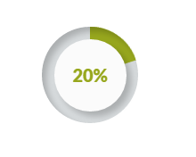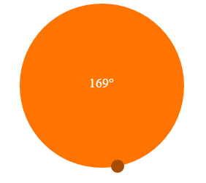

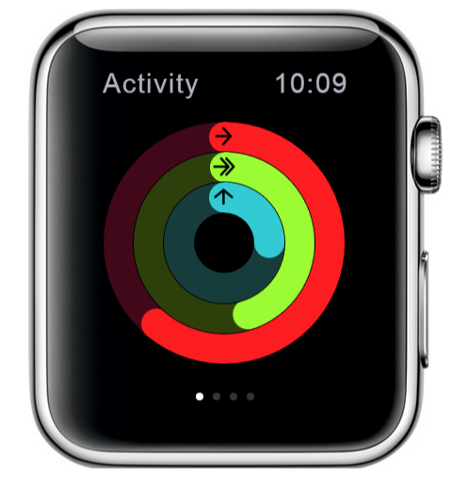

Motives for Portfolio Page:

* Instead of square nodes, we can display circular nodes that show the status of an asset.
* Give the user the freedom to hide/show certain fields.
* Use visual arrows to show gains/losses
* Main panel will contain tree. Right Panel will contain chart visualizations
* Bottom Panel will contain various tables/options. TBD.
* At specific percentage zoom in views, dynamically change the visual structure of tree.

**Current Code**

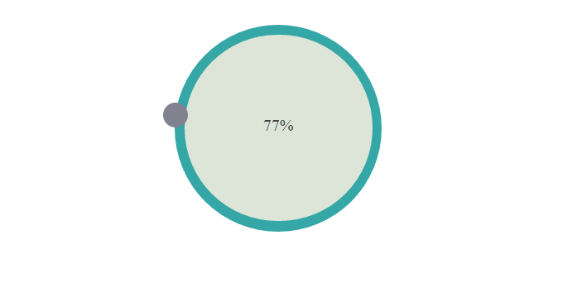

* Current: Circular Dial that users can drag to increase/decrease percentage
* Future: Looking to adding a second dial to indicate current position and a "visual" drift.
* Future: User can then balance asset by dragging dial1 to dial2's coordinates.
* Future: User can also increase asset's target percentage by moving dial2.
* Not available on the github yet.

Research To Be Continued...